THE LOGIC FORGE ACTIVITY

Solution Outputs:

Problem1:
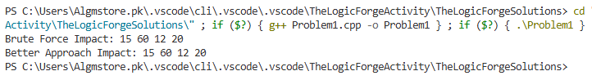
Problem2:
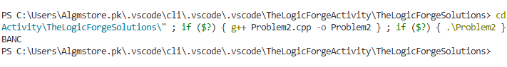
Problem3:
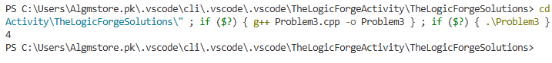
Problem4:
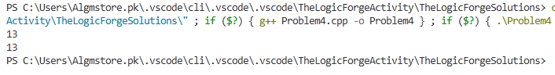
Problem5:
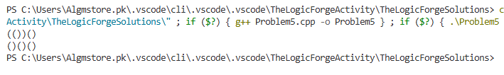

Problem6:
